Ingredients:
Baking Potatoes
Olive oil, vegetable oil, or butter
Coarse salt or sea salt (optional)

How To Choose Potatoes for Baking: Any potato can be baked, but for the perfect baked potato with the desired flaky texture, it is recommended that mature, baking-type potatoes such as the Russet potatoes be used. Russets are known as a starchy potato, a baking potato, or a mealy potato. The starch gives the potato it's characteristic fluffiness.
Make sure that the skin has a nice even brown tone without a greenish cast. Inspect the potatoes thoroughly to make sure that there aren't any significant bruises, discolored spots, or sprouts.
A sprout of any size can be toxic, but you'd have to eat many sprouts to get sick. Do not buy potatoes if they have sprouted or have a green tint to the skin. The same is true for potatoes that turn a greenish hue. A potato in this condition is "light-struck" which causes a build-up of a chemical called Solanine. This is a natural reaction to the potato being exposed to too much light. The green part, if eaten in large quantity, can cause illness.
When baking a large amount of potatoes at one time, choose potatoes with uniform shapes and sizes; they will cook more evenly and get done at the same time.

Preparation:
Adjust the rack in your oven to the middle position and preheat oven to desired temperature (see Cooking Temperature Chart below).
Rinse and scrub (I use a stiff-bristled brush) each potato under cold running water, as you will be eating the skins of these perfect potatoes. Don't soak the potatoes (that will make them soggy. Do not use hot water or you'll start cooking the outside and the inside won't catch up). A majority of the vitamins and minerals are found in the skin, so don't throw it away. Dry each potato thoroughly with a clean towel.
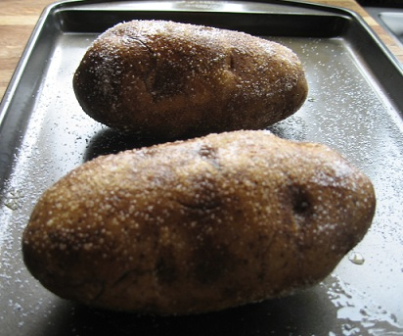Look the cleaned potatoes over and remove any bruises or discolored spots with the tip of your knife.
Pierce each potato deeply with a fork or sharp knife four (4) times on each side at approximately 1-inch intervals. This will allow steam to escape during the baking. If you don't pierce the potatoes, they may explode during baking in your oven. You don't want this to happen as it makes a terrible mess in your oven!
Wrapping the potato in aluminum foil will produce a soft skin (not crispy). Technically this is steaming rather than baking (as the moisture in the potato remains trapped) and the light, flaky texture will be missing. The texture of a steamed potato is entirely different from that of a perfect baked potato. Save yourself the trouble and expense of wrapping potatoes in aluminum foil and serve perfect baked potatoes. My suggestion is to NEVER use aluminum foil when baking potatoes!
For a soft potato skin, rub the outside of the potato with olive oil, vegetable oil, or butter over the skins. I like to roll the potatoes in coarse or sea salt after rolling in the oil and before baking. Place coarse salt onto a small plate. Roll potatoes lightly in the salt. The skin is so yummy to eat!
Bake on racks of oven until tender.
Bake according to the Temperature Chart below. Do not overcook potatoes as the insides will be dry, so it's important to be vigilant.

